Hydrogen Process Modeling and Optimization Process
About
Hydrogen is proposed as a green energy source to use in the power turbines and hybrid cycles, fuel cells, and vehicles to produce electricity and heat without emission of carbon and nitrogen oxides and soot.
The partial oxidation, steam reforming, and auto-thermal reforming of hydrocarbons, coal and biomass gasification and electrolysis are common routes to produce hydrogen. The purpose of modeling and optimization is to improve, analyze and predict Hydrogen production.
Hydrogen production depends on a number of variables, including pH, temperature, substrate concentration and nutrient availability, among others. Mathematical modeling of several distinct processes such as kinetics of reactants and products formation, steady state behavior of substrate along with its utilization and inhibition have been great impact on Hydrogen production. Hydrogen Process Modeling and Optimization Process, summarizes the experimental design methods and investigate effects of various factors on hydrogen production, In addition, the applications of artificial computational network are component analysis and optimization process are finding desirability function and cost estimation of the total process.
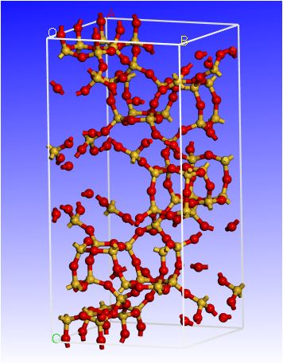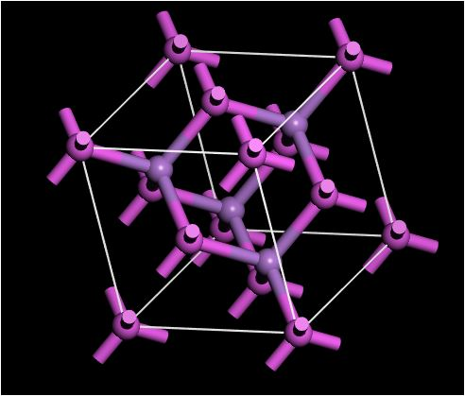
Various optimization strategies have been used for Hydrogen process modeling. Design of experiment is a structured method by which certain factors are selected and deliberately varied in a controlled manner to obtain their effects on the output of a process, often followed by the analysis of the experimental results. It should predict the important parameters and the relationship between them.

The main goal of this research is the modeling and optimization of an industrial hydrogen production unit from Biogas and photo catalytic water splitting. The simulation results Show that applying the proper optimal condition on the system increases hydrogen production Capacity.
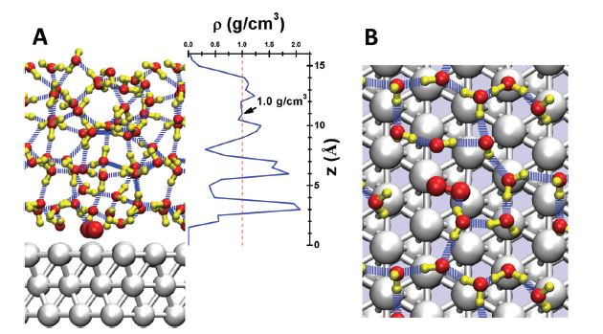
It is worthwhile to note that any hydrogen process depends largely on optimization of several Controlling factors. This is only possible through modeling of the factors that determine process rate.

